Tommy Aguilu

8/12/2019

Foundations of Programing

Assignment 6

Knowledge document

Introduction – The goal of this program is to refactor old code to introduce classes to help wrap our functions into a single class.

Code Snippet

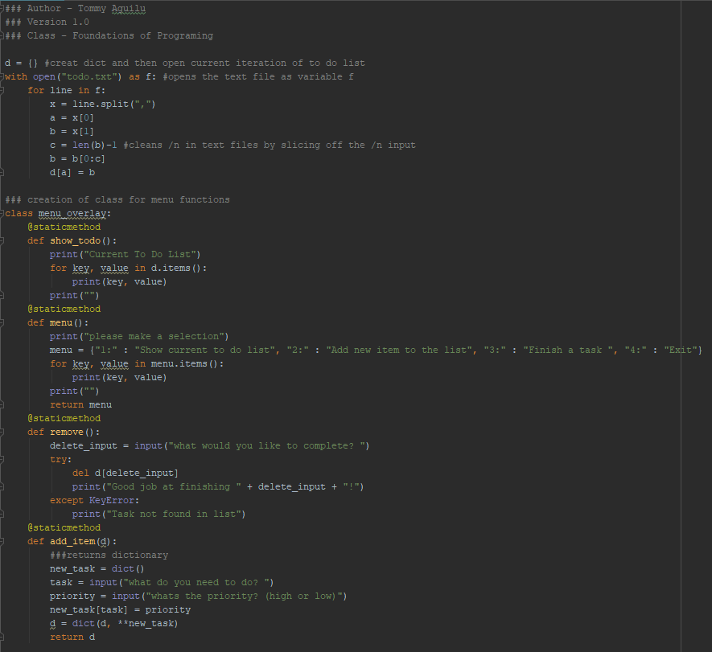

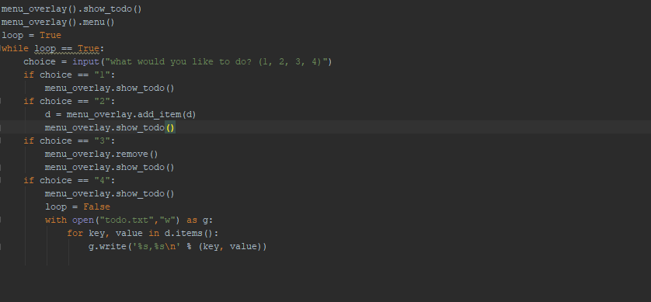

Section 1 – Importing to do file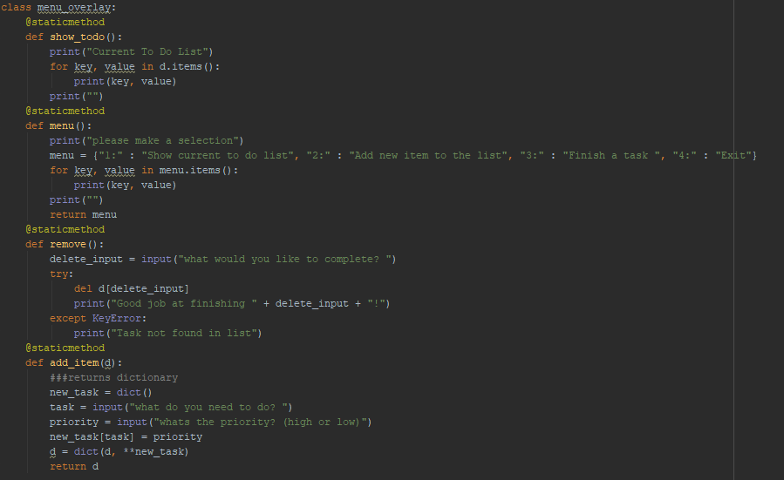

In this section we wrap all the various code snipets previously used into classes. This encapsulates the code better and allows us to create a cleaned-up section of code later in the program.

Section 2 – Script

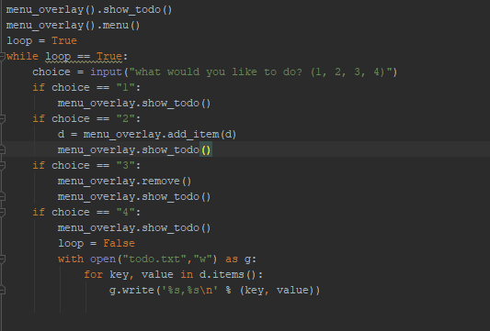

In this section we create a simper and more defined class and method structure. This reduces the lines of code for the total program from 30 lines and 894 characters, to 18 lines and 581 characters.

Conclusion – In this assignment I set out to create a function that could retain the functionality from assignment 5 but with the added benefit of leveraging wrapped functions. To do this we wrapped the original lines of code from each choice into their own defined functions under the class menu_overlay.

Output

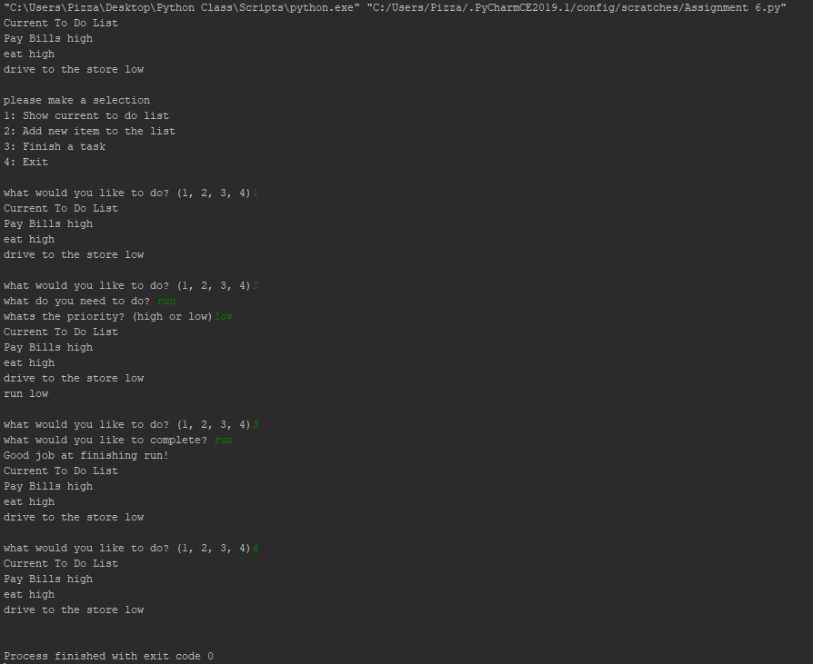

Saved file

